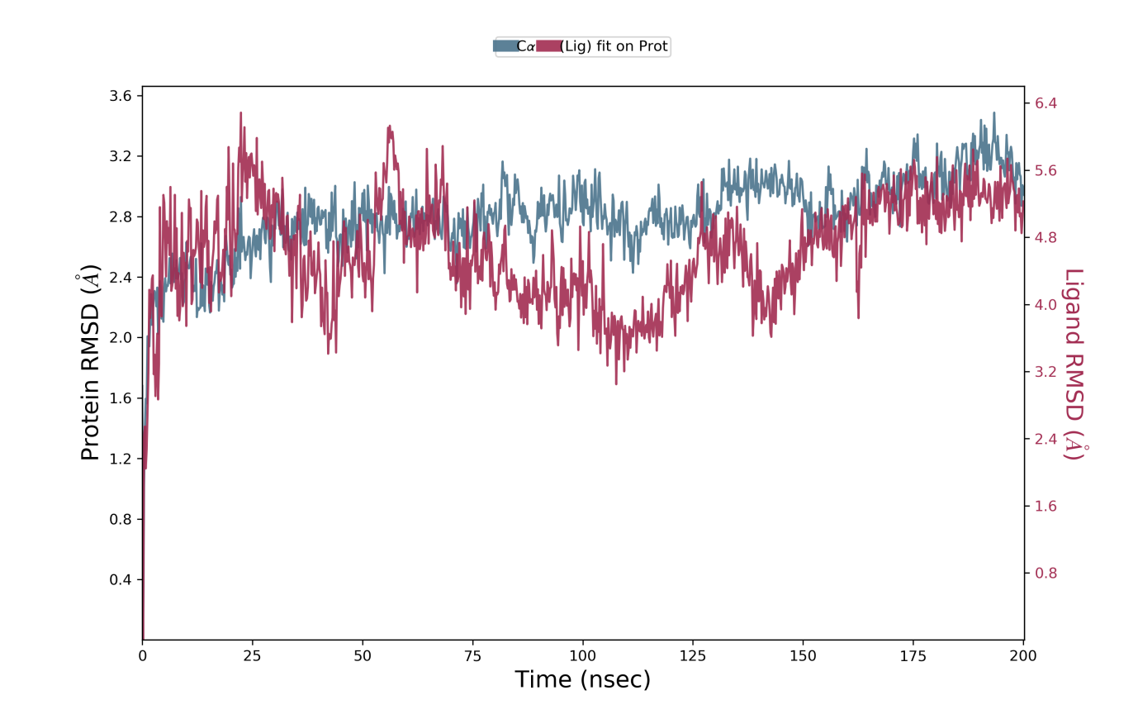
Supplementary Fig. 1. Protein Ligand RMSD of TBK1-ZINC02095133.

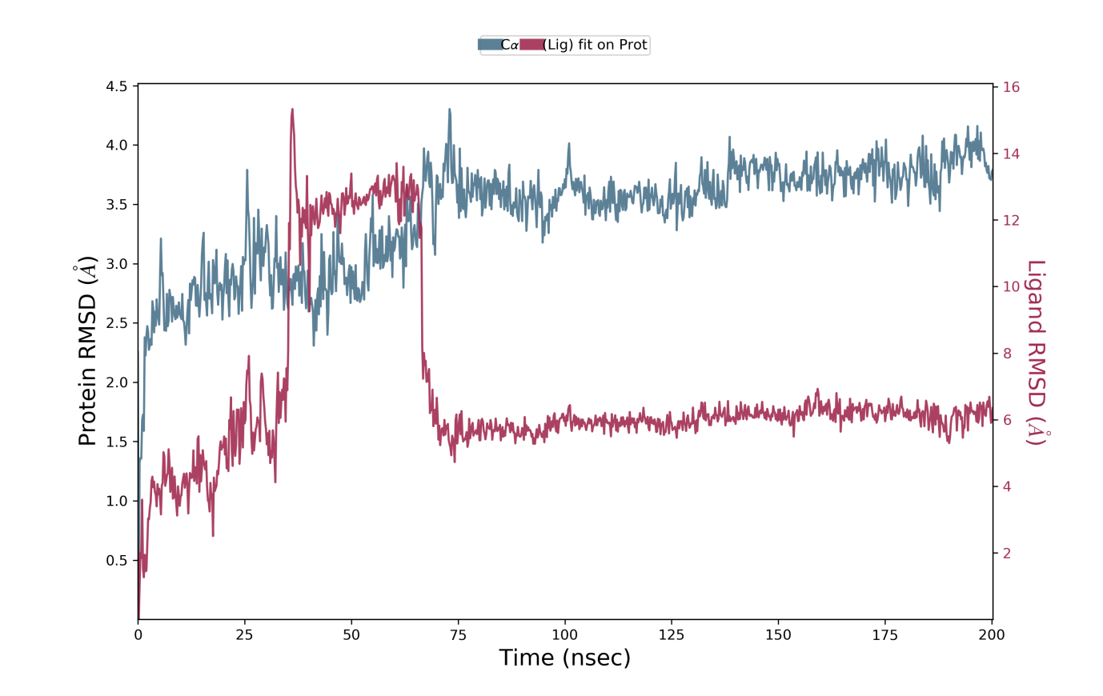
Supplementary Fig. 2. Protein Ligand RMSD of TBK1-ZINC02130647.

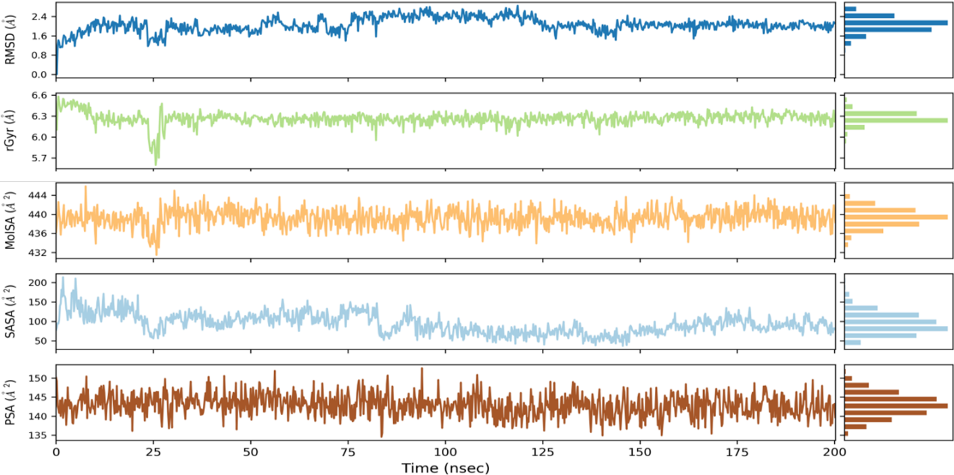
Supplementary Fig. 3. SASA plot of TBK1-ZINC02095133.

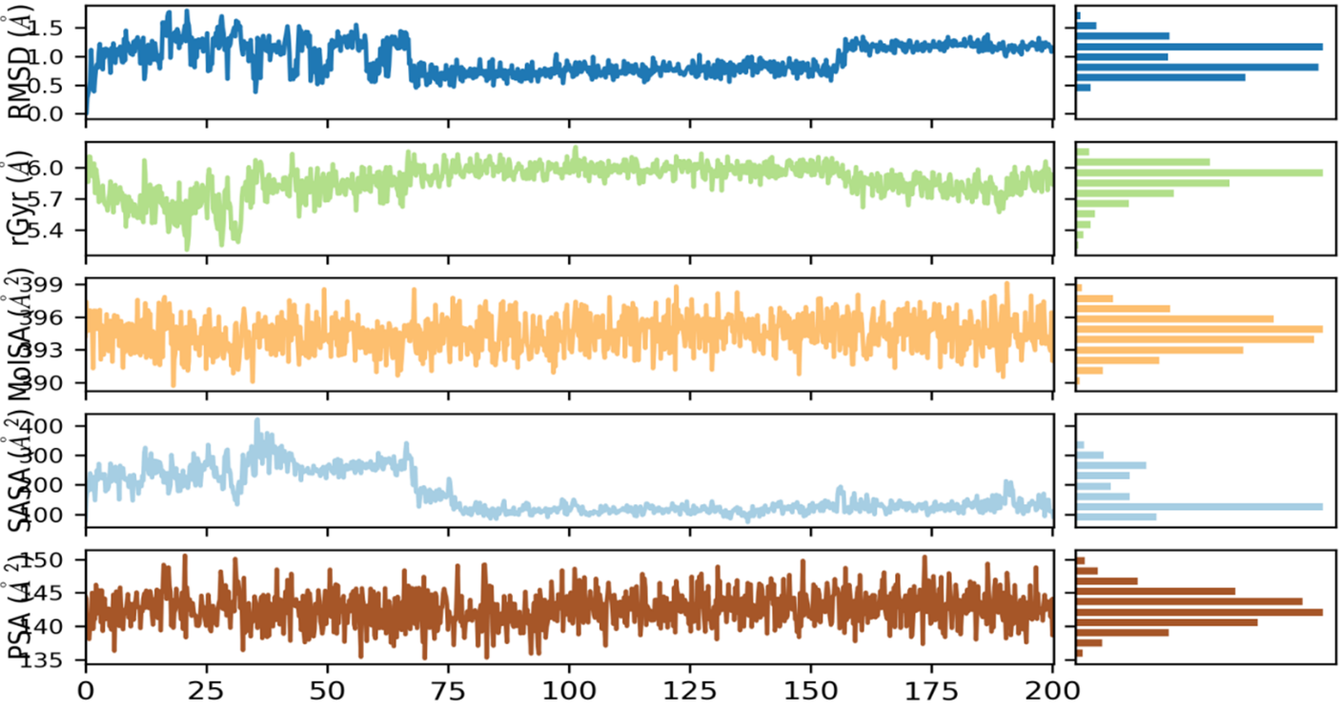
Supplementary Fig. 4. SASA plot of TBK1-ZINC02130647.

